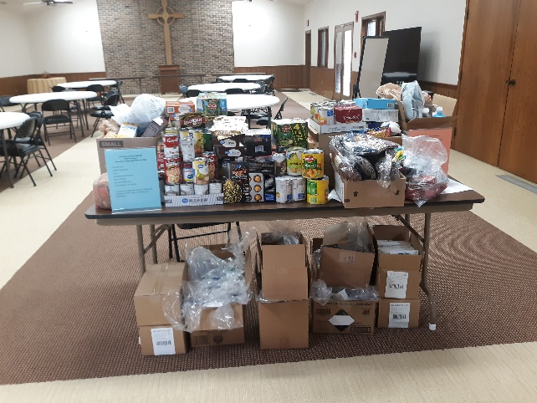
Many Thanks!
Many thanks to the many people who donated time, donations, and money to make the 135th Anniversary Challenge a success. We were able to provide to four community agencies food, clothing, and other supplies. The generosity of Garden City Presbyterian Church and members was felt throughout the community!

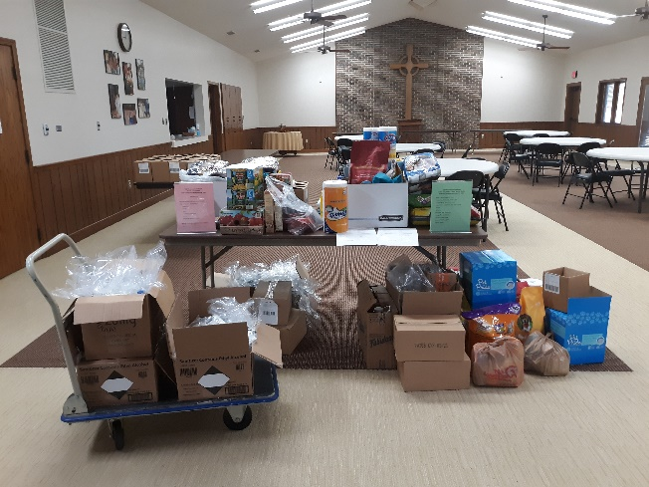
We delivered to Genesis. The Animal Shelter, Family Crisis Center, and Emmaus House picked up from here. Some people had never been inside this Church and expressed how inviting it is. There were also people who were amazed at the generosity of the members and friends.

Delivery to Genesis Pick up by Emmaus House

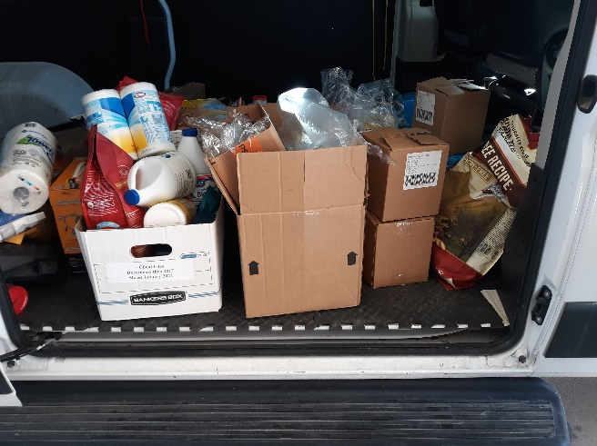
Pick up by Animal Shelter
We are living into our two Matthew 25 commitment to eradicate systemic poverty and to build congregational vitality. We have accomplished this by inviting community who have never been in the building here and we are providing basic necessities for those on the margins of society.
Thank you from the 135th Anniversary Committee
Matthew 25:34-40
³⁴ “Then the King will say to those on his right, ‘Come, you who are blessed by my Father; take your inheritance, the kingdom prepared for you since the creation of the world. ³⁵ For I was hungry and you gave me something to eat, I was thirsty and you gave me something to drink, I was a stranger and you invited me in, ³⁶ I needed clothes and you clothed me, I was sick and you looked after me, I was in prison and you came to visit me.’
³⁷ “Then the righteous will answer him, ‘Lord, when did we see you hungry and feed you, or thirsty and give you something to drink? ³⁸ When did we see you a stranger and invite you in, or needing clothes and clothe you? ³⁹ When did we see you sick or in prison and go to visit you?’
⁴⁰ “The King will reply, ‘Truly I tell you, whatever you did for one of the least of these brothers and sisters of mine, you did for me.’
Genesis 1:26
²⁶ Then God said, “Let us make humankind in our image, according to our likeness; and let them have dominion over the fish of the sea, and over the birds of the air, and over the cattle, and over all the wild animals of the earth, and over every creeping thing that creeps upon the earth.”

